Chapter 14, Solution 49.

Design a problem to help other students to better understand lowpass filters described by transfer functions.

Although there are many ways to solve this problem, this is an example based on the same kind of problem asked in the third edition.

Problem

Determine the cutoff frequency of the lowpass filter described by

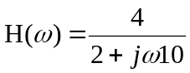

Find the gain in dB and phase of H(ω) at ω = 2 rad/s.

Solution
At dc, 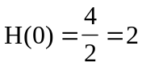.
Hence, 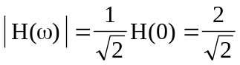

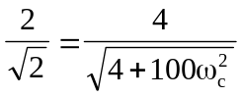

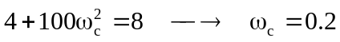

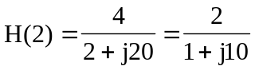

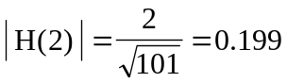

In dB, 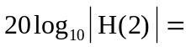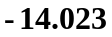

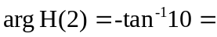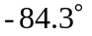 or ω_{c} = 1.4713 rad/sec.

